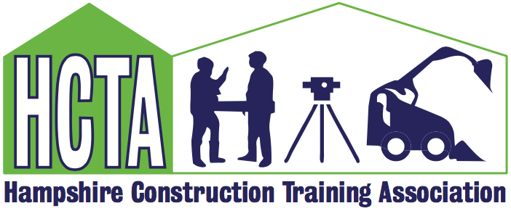

AGM & Members Meeting March 11th 2025

CETC Civil Engineering Training Centre, Fareham, Lee-on-the-Solent, PO13 9FU

TEA & COFFEE FROM 09.30 AM

10.00am: WELCOME & INTRODUCTIONS - JULIA COAK

10.10am: AGM
- Chair Report
- GTO Report
- Financial Report
- Proposals

10.30am: CITB UPDATE – JACQUEE SAY & WILLIAM CAMPBELL

10.40am: STEFANIE DANIELS EMPOWERING HEALTH: MENOPAUSE
AWARENESS & BIO HACKS FOR ALL FOR WORKPLACE WELLBEING

11.10am: BREAK

11.20am: CSCS UPDATE - GARY MORTIMER EXECUTIVE DIRECTOR CSCS

12.00pm: A.O.B

12.15pm: NEXT MEETING & CLOSE - JULIA COAK

12.30pm: HCTA COMMITTEE MEETING

