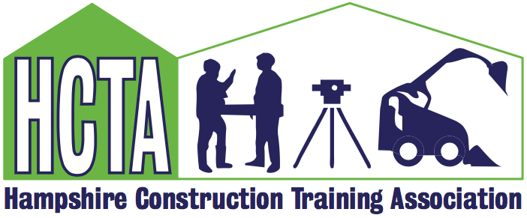
HCTA Members Meeting and AGM Notes – Tuesday 13th March 2024 at 10.00am at CETC

- Julia Coak, HCTA Chair welcomed everyone to the meeting and welcomed GSJP (South) Ltd as new members and new representatives from RW Armstrong and Hughes & Salvidge.

- A.G.M:
- Chairman Report 2023 – see below
- Training Officer Report 2023 – see below
- Financial Report 2023 – Accounts submitted and correct
- Proposals were all agreed by those present and voting beforehand:
- Election of Officers
- Acceptance of 2024 Accounts
- Annual Subscription 2024
Chair Report

A recap on meetings and events held the previous year. The focus for 2024:

- Invite informative and enlightened speakers to our meetings.
- Make our four annual meetings a great space for networking, sharing of ideas and excellent business practice.
- Discuss and highlight the hot topics of the day – social values, our green agenda, skills enhancement and careers.
- Be available to offer guidance, support and advice.
- Deliver bespoke training as guided by the needs of our members.
- Encourage new members through updating our website, being more visible on Social Media and liaising with potential new CITB Employer Networks.
- Support the i-construct 2024 event and encourage young people to consider the construction industry as their career.

GTO Report

Administration Grant 2024/25 confirmed with no funding from CITB this next financial year regarding training. HCTA will subsidise some training and members can still claim grant, so it will be to their benefit. Employer Network Group operating in Dorset now and waiting to hear from CITB if one will be available in Hampshire. Carolyn will check if in the interim HCTA members could use the Dorset EN funding to host courses in Hampshire. Courses proposed going forward this year are Leadership & Management, Suicide awareness, SEATS, MHFAR. A video promoting the forthcoming Training & Coaching in Construction course was shown. Please contact Carolyn if you would like to see any specific training organised through HCTA that would benefit members. Subscriptions remain the same at £100 as in 2023 and will be invoiced in April.

- IConstruct Update – Jason Woodward
Definite dates in diary for 17/18 October 2024. Jason will be holding a meeting in the near future and requested as much support as possible from HCTA members so this year will be as successful as previous. Contact Jason if you want to be involved or need more detail.

- CITB Update
Maggie Stefaniak was unable to attend but had sent slides to update everyone. Maggie is leaving CITB at the end of March and is going to be missed but she will stay in contact with HCTA! Carolyn will keep members updated with regard to the new Local Engagement Advisor.

- HCTA Promotional Video Update – Luke Parker
Luke provided an update on the importance of promoting on social media. He was present throughout the meeting filming and interviewing members to create a piece that can be used on the website and on Linkedin to promote HCTA and attract new members. Details will be sent to all members when completed so they can share.

- Presentation – Building for Heroes Education Foundation – Nicola Schneider
Nicola Schneider provided an excellent insight to the challenges veterans face and the support that Building for Heroes can provide with training specifically for construction. Several HCTA companies are working with veterans and Nicola has welcomed ongoing contact with HCTA with a meeting planned for the near future to progress with training/recruitment issues. Nicola would welcome contact from anyone that may be interested to learn more.

- AOB

Michelle Scott raised IWCTG involvement with the Bear Rescue Project, at the Wildheart Animal Sanctuary on the Isle of Wight. Some HCTA member companies work on the Island and some materials regarded as waste, may well be of use to the Animal Sanctuary, to find out more or help contact Michelle.

- Dates for 2022 meetings
11th June
10th September
3rd December
Meeting closed at 12.30pm.

