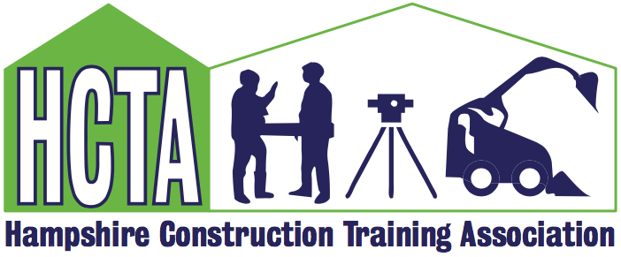

AGM and Members Meeting 22nd June 2021
CETC, Fareham

Julia Coak, HCTA Chair, opened the meeting. 24 were present representing 16 HCTA member companies. Apologies had been received from the remaining 17.

Presentation from Dave Richardson, Director of CEMAST and CETC: providing an overview of the delivery programmes running from CETC and Construction. Dave would like to hear from employers through HCTA of how CETC can support their training needs and the recruitment of the future talent within the industry. David.Richardson@fareham.ac.uk. A copy of the presentation will be available on the website.
Chair Report 2020: New website created. Successful face to face Members meeting September 2020 with speakers on Mental Health and EDI. Lego Challenge continued between lockdowns and £5.5k funded by CITB towards training schools and supplying kit. Career funding now stopped in new financial year, but HCTA will pick up the shortfall to complete the project in 2021/2022. HCTA funded 2-day MHFA course in December. CITB now place HCTA as part of South-Central area. Reduction in Levy impacted on admin grant and was reduced to 60% for a period of time. CITB funding for 2021 now at reduced rate of £24k with no GET funding although Skills & Training fund will still be available for companies to bid for on an individual basis. HCTA can assist if required.
Looking forward to 2021/22
Thanks to all the hard work put in by Carolyn and the committee over the last year and a big welcome and thanks to Gary Mann and Maggie Stefaniak for agreeing to come forward to the committee.
The HCTA sees itself as more than just a “training” group. We of course will continue to offer the training support that we always have including discounted courses, help and advice and introductions to local training companies. But we also believe in championing the industry in our local area and nationwide by looking at the bigger picture!
We will do this by:
- Supporting local Career events and encouraging young people to consider the construction industry as their career.
- Inviting informative and enlightened speakers to our meetings.
- Making our four annual meetings a great space for networking, sharing of ideas and excellent business practice.
- Discussing and highlighting the hot topics of the day – climate change, mental health & pandemics!
- Being available to offer guidance, support and advice.

- Proposal for election of officers on committee had been agreed with membership electronically beforehand as had acceptance of 2020 financial reports. Annual subscription had been increased to £100 in 2021 and will remain in 2022.

Jacquee Say provided a CITB Update:
Shirley Ratcliffe - Senior Customer Engagement Manager South East
Elizabeth Steel - Customer Engagement Manager – South East- Central Region
Jacquee Say - Customer Engagement Advisor – East Hampshire / Solent PO Postcodes Main Advisor for HCTA
Heidi Greenham - Customer Engagement Advisor – West Hampshire / Solent IOW – Main Advisor for IOW Training Group
Grants
CITB are now supporting Higher Apprenticeships and Employers may value the grant available for training as it is now £2500 per year, and £3500 on achievement instead of
£1,125 per year and £1875 achievement. This would be HNC / HND delivered as an apprenticeship.
Travel to Train
CITB is widening the support offer for employers with apprentices who must 'Travel to Train'. CITB will fund 80% of accommodation costs for eligible apprentices of grant eligible employers who attend colleges or training providers where overnight stays and travel to and from a hotel to a place of training, are required. Employers can also claim excess costs for apprentice travel where the cost exceeds £30 per week.
Webinars
As your Advisors, we will be running webinars throughout the year covering a range of topics. Both Training Groups will receive a list of the up-and-coming events and how to book onto them.
CITB Guide to Construction Apprenticeships – Tuesday 20th July at 10.00am
CITB Grants & Funding 2021/22 – Thursday 5th August at 2-00pm
Work Experience Grant
This grant for Graduates needs to be claimed by 30/10/2021. As it will then be removed.

Story Telling in Business - Monique Wintle-Camp provided a brilliant presentation:
“Standing out in business has never been so important. Finding ways to create connections quickly, make yourself memorable and generate trust is integral to any business. During this session you will understand how to use personal and business stories to make a stronger emotional connection between you and your client. We will cover the why and how storytelling works and a structure on how to create, connect and land stories. Use stories with confidence when creating new connections, convincing an audience and have a lasting impact.” For further information please contact Monique direct: monique@wintle-campcoaching.co.uk

HCTA 2021 – Carolyn provided an update on what had been happening in the first quarter of the financial year; MHFA training and IEMA virtual training with a leadership and development course funded through GET. Discounts are still available with training companies although some have withdrawn because of the pandemic situation. CITB GET funds are not available for TG’s now, but the administration grant will be paid at a reduced rate. CITB require evidence of training activity within the group and Carolyn will be in touch with further details of how members can help.

I Construct – Jason Woodward explained that HCTA would still be progressing with this exciting event, although because of the pandemic it would be in the autumn term of 2022. Schools within Hampshire will be invited to participate with the aim to encourage young people to consider the Construction Industry as a career choice, with a strong emphasis on getting girls to interact. Jason will be organising a meeting with the original working party in this Autumn and will keep the group updated. If you want to be involved or find out more contact: jason.woodward@ptcontractors.co.uk

A.O.B – no comments

Committee meeting held after the main meeting agreed future meeting dates of 14th September and 7th December to be held at CETC

